STUDENT PERFORMANCE ANALYSIS AND PREDICTION
INTRODUCTION
. Student Performance analysis plays an important role in understanding the academic progress of students. Educational institutions can use Data Analysis and Machine Learning technique to identify factors affecting performance and predict student outcomes. This project aims to analyze student performance data and develop a machine learning model to predict whether a student will pass or fail.
DATASET DESCRIPTION
The dataset used in this project is the student performance dataset containing 1000 student records.
Features Used,
1. Gender
2. Race/ethnicity
3. Parental level of education
4. Lunch type
5. Test preparation course
6. Math score
7. Reading score
8. Writing score
Target Variable
Result
Pass = math score >= 40
Fail = math score <40
Dataset Information
- Total Record : 1000
- Total Features : 8
- Dataset Type : Structured Data
- Task Type : Classification
DATA PREPROCESSING
1.Data Loading
The dataset was loaded using the pandas library.
2.Data Inspection
. Checked dataset dimensions
. Verified data type
. Examined sample records
3.Missing Value Analysis
The dataset was checked for missing values.
Result: No missing values were found.
4.Categorical Encoding
Categorical variables were converted into numerical values using Label Encoding.
Encoded Columns:
- Gender
- Race/Ethnicity
- Parental Level of Education
- Lunch Type
- Test Preparation Course
5. Target Variable Creation
Pass and Fail label were generated based on math score.
6. Train-Test Split
The dataset was divided into:
• Training Data : 80%
• Testing Data : 20%
Exploratory Data Analysis (EDA)
EDA was performed to understand the data distribution and identify patterns.
Gender-wise Performance Analysis
The performance of male and female students was compared using box plots.
Observation: Female students generally performed better in reading and writing scores.

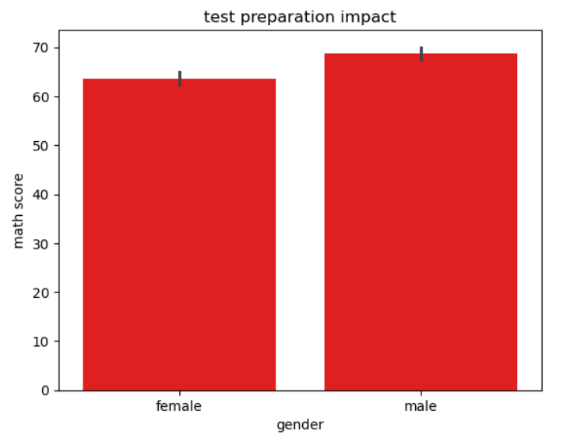

Math Score Analysis
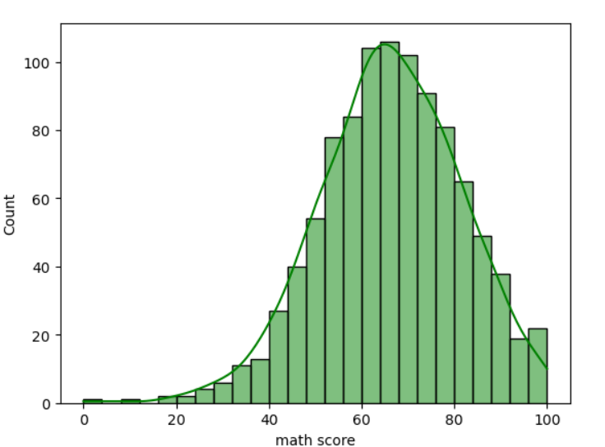
Lunch Type Analysis
Students with standard lunch performed better than students with free/reduced lunch.
Observation: Lunch type has a moderate effect on academic achievement.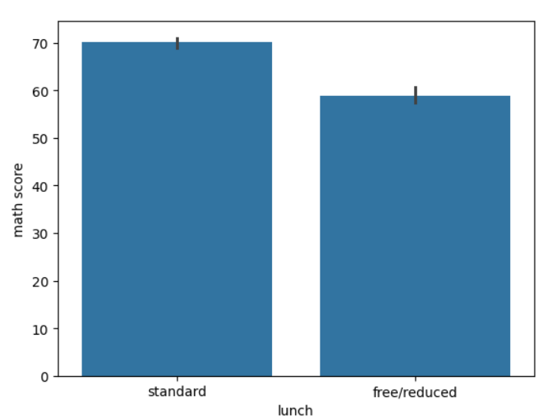

Correlation Analysis
A correlation heatmap was generated.
Observation: Math,Reading and writing scores showed strong positive correlation.
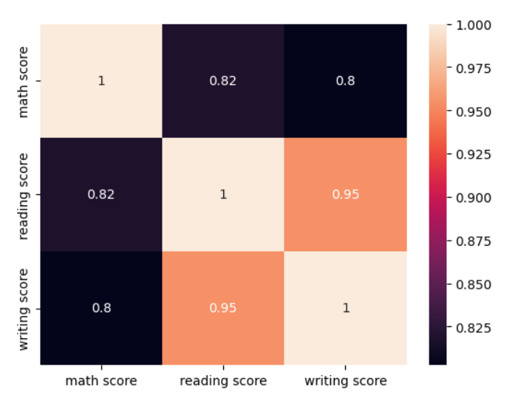
Model Building
Three machine learning classification models were implemented.
Logistic Regression
Logistic Regression is a supervised machine learning algorithm used for binary classification problems.
Advantages:
Fast
Easy to interpret
Good baseline model
Decision Tree Classifier
Decision Tree creates decision rules based on feature values.
Advantages:
Easy visualization
Handles nonlinear relationships
Provides feature importance
K-Nearest Neighbors (KNN)
KNN classifies records based on similarity to neighboring samples.
Advantages:
Simple implementation
Effective for classification tasks
Results
The models were evaluated using Accuracy Score.
Model Comparison
Model Accuracy, Logistic Regression -> 99.5% Accuracy.
Decision Tree -> 100% Accuracy.
KNN -> 99.5% Accuracy
The best-performing model was selected for deployment.
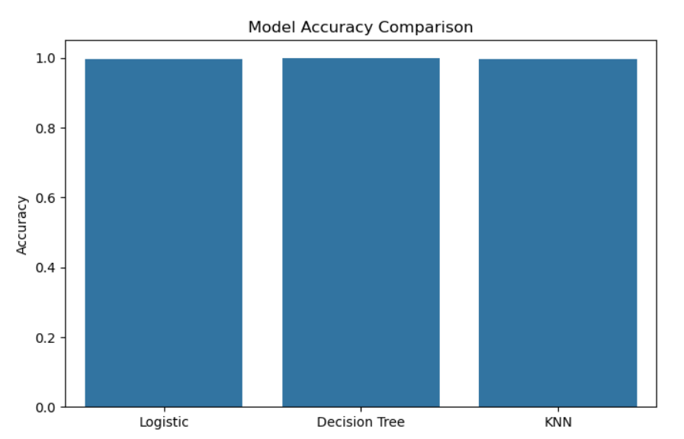
Insights
Students completing test preparation courses scored higher.
Reading and writing scores are highly correlated.
Standard lunch students performed better than free/reduced lunch students.
Math score was the strongest indicator of pass/fail status.
Parental education level had a moderate impact on student performance.
Conclusion

This project successfully analyzed student performance data and implemented machine learning models to predict student outcomes.
The project demonstrated how educational data can be used to identify performance patterns and support academic decision-making. The developed model can assist educators in identifying students who may require additional support.
The project was successfully deployed using Streamlit, allowing users to enter student information and obtain predictions through a simple web interface.

--- the end ---

